DBMS PROJECT FINAL REPORT

PROJECT TITLE :GYM MANAGEMENT SYSTEM

|  |  |
| --- | --- |
| TEAM MEMBERS | SRN |
| M.SRAVANI | PES1UG22CS315 |
| SRAVYA MATTA | PES1UG22CS337 |

**E-R Diagram**

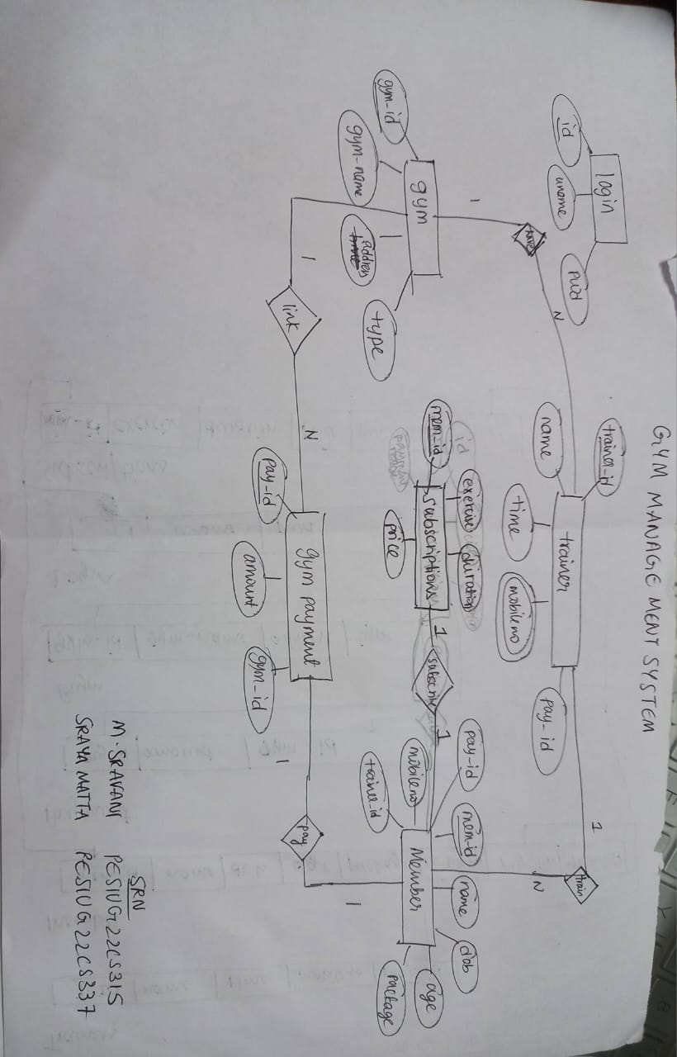

**Relational Schema**

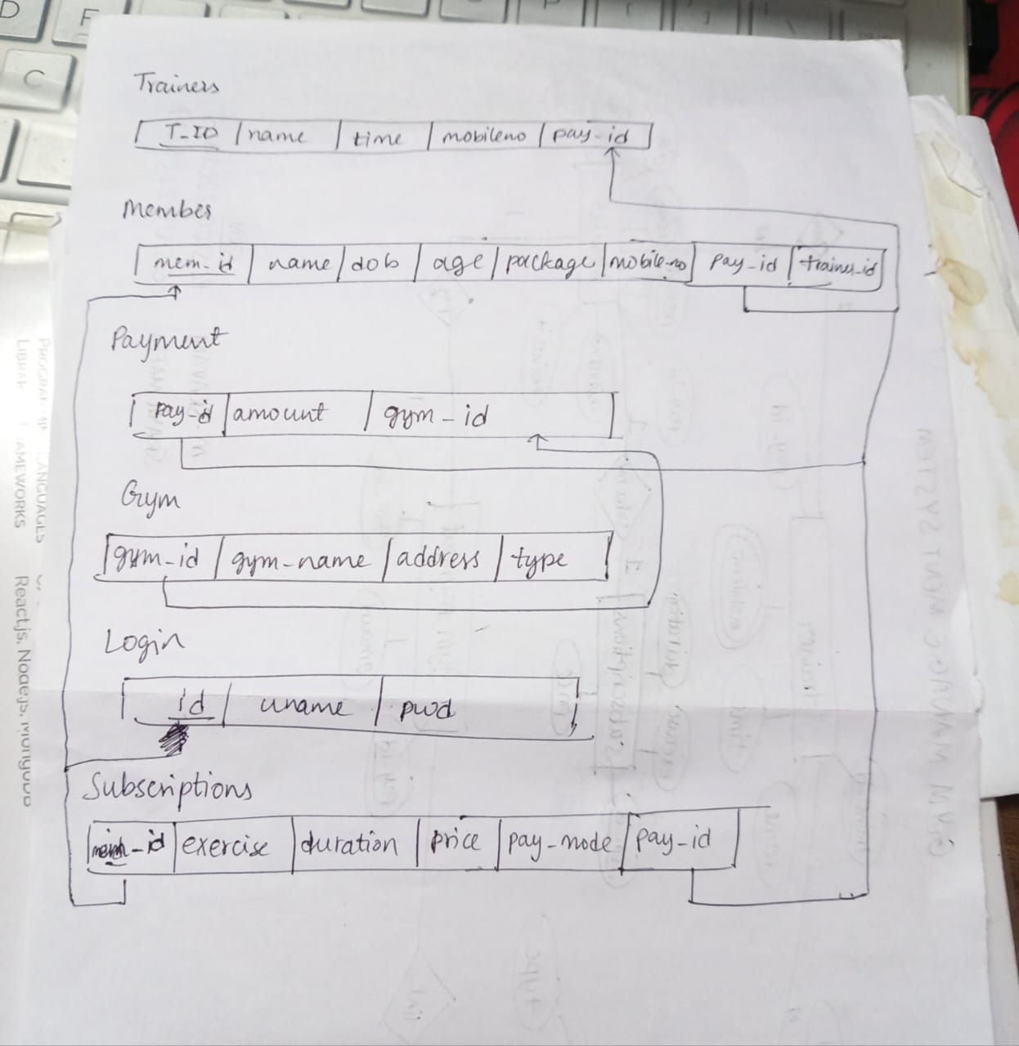

**Code snippets and screenshots for queries**

Create Commands

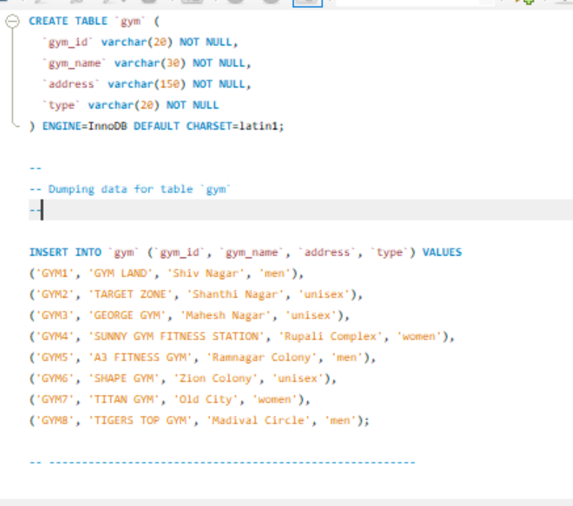

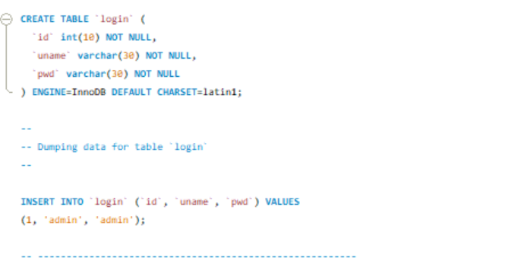

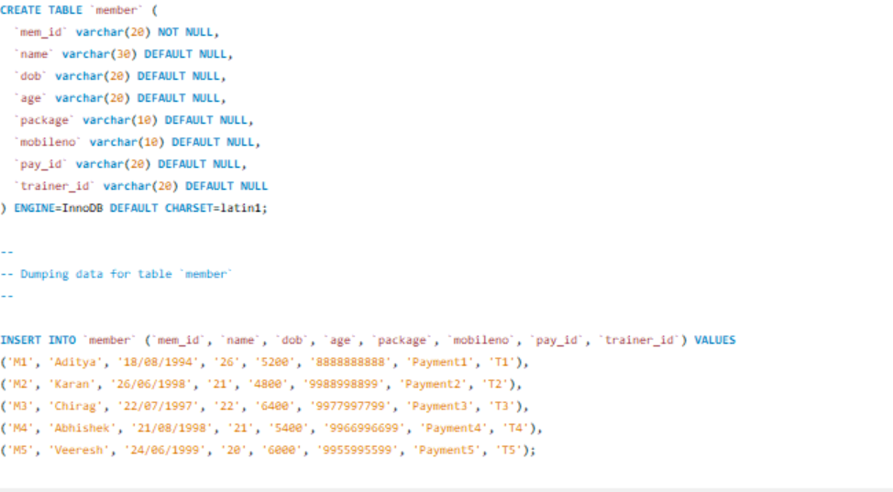

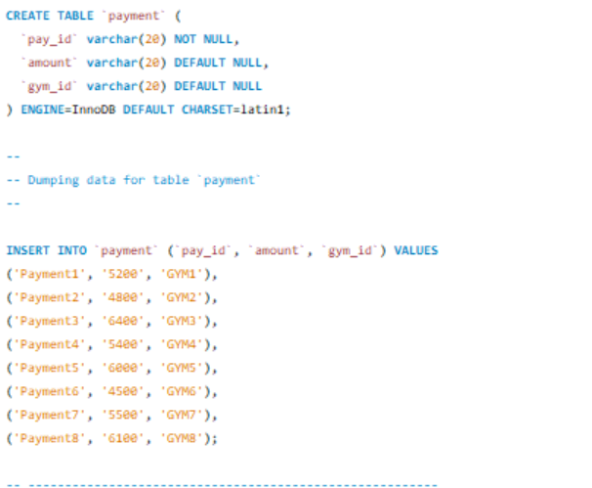

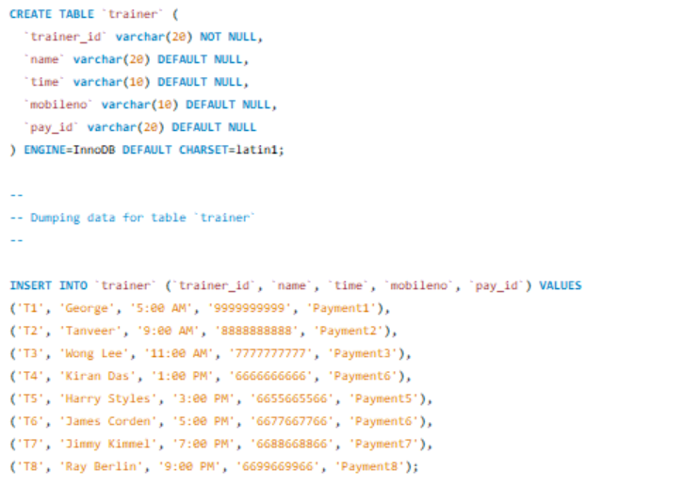

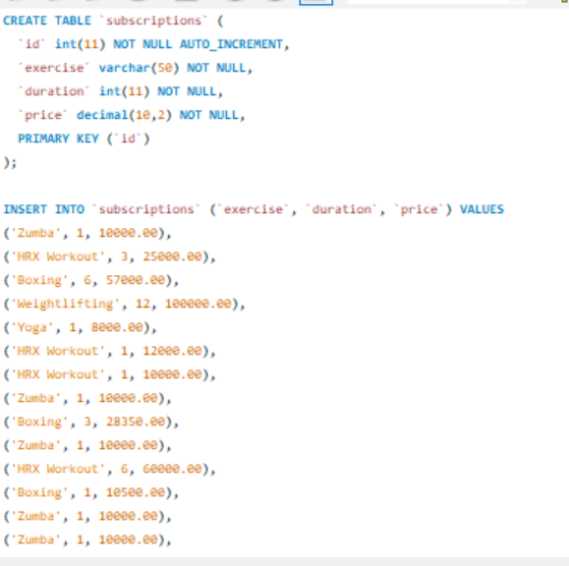

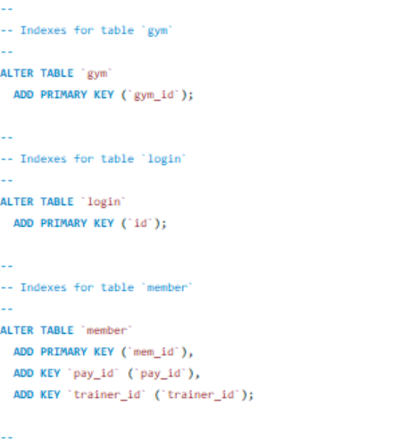

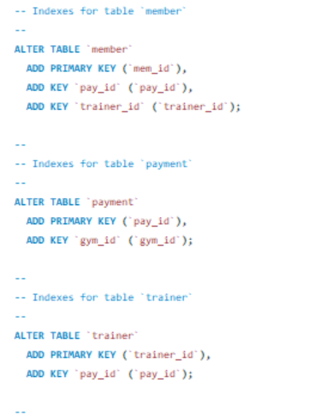

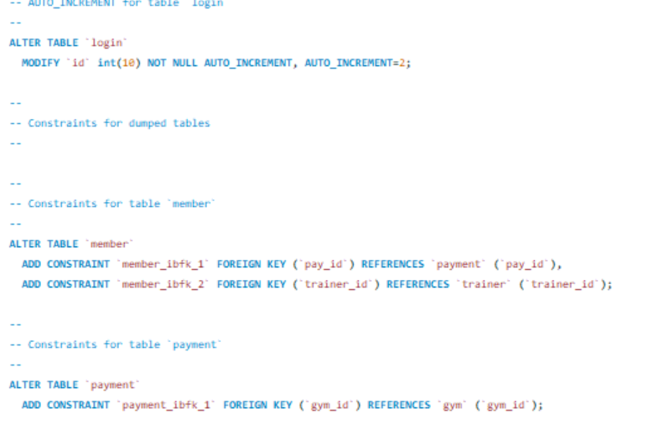

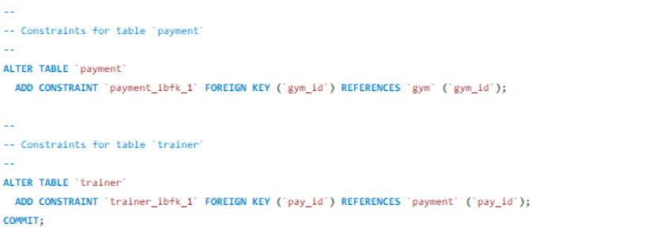

UPDATE

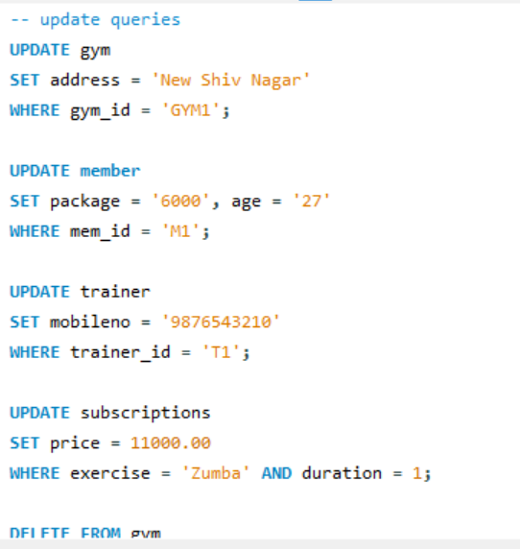

DELETE

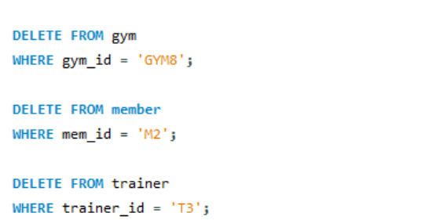

TRIGGER FOR CHECKING BEFORE MEMBER INSERT

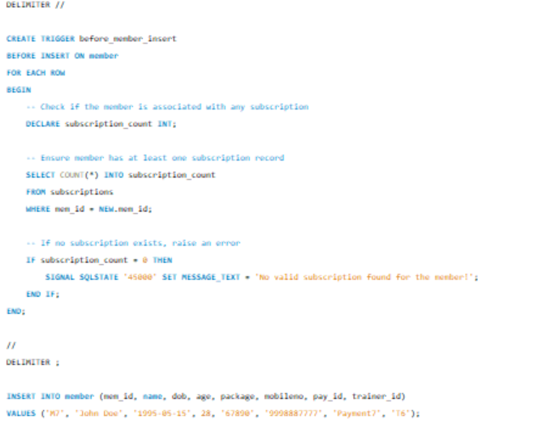

STORED PROCEDURE FOR ADD SUBSCRIPTION

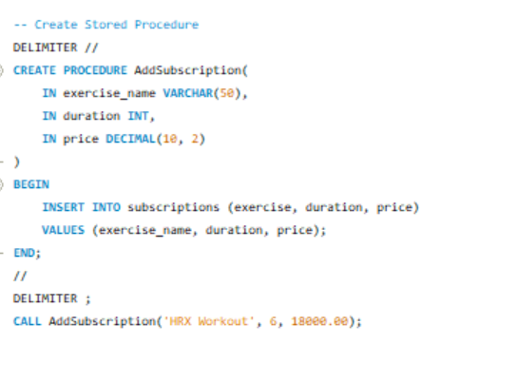

FUNCTION TO GET PAYMENT AMOUNT WITH PAYMENT ID

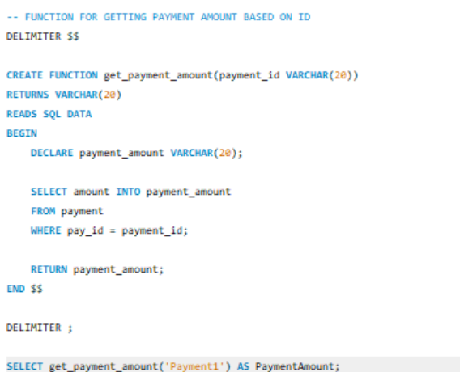

Nested and join

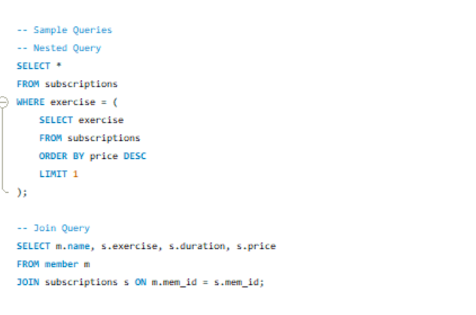

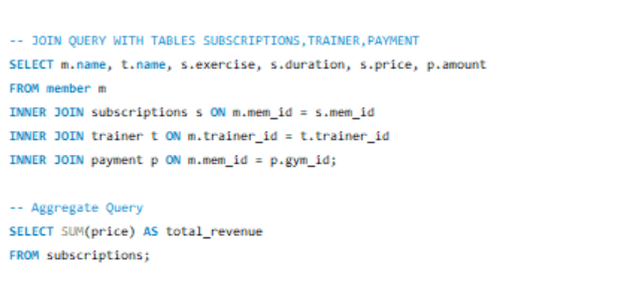

PROCEDURE TO CALCULATE TOTAL COST

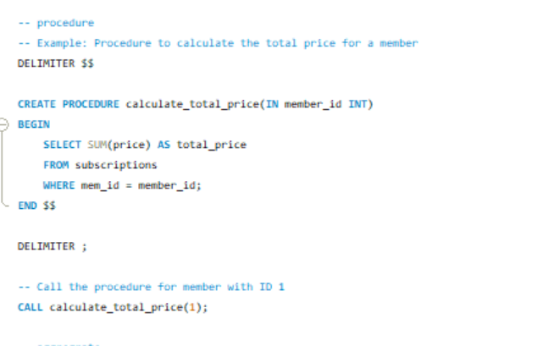

Aggregate query to get number of subscriptions(exercise type) and average price

